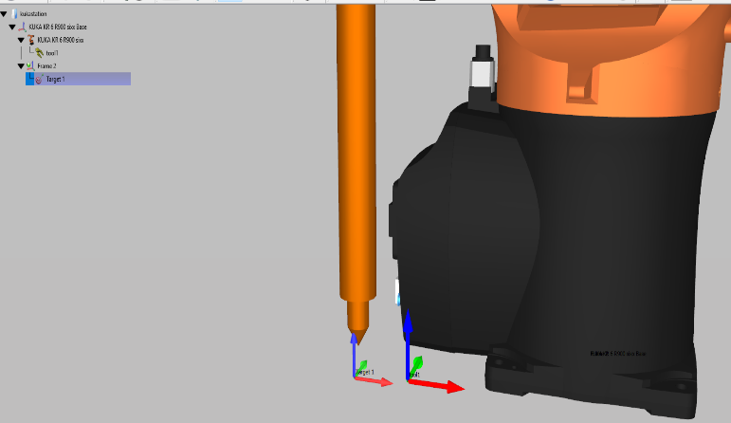

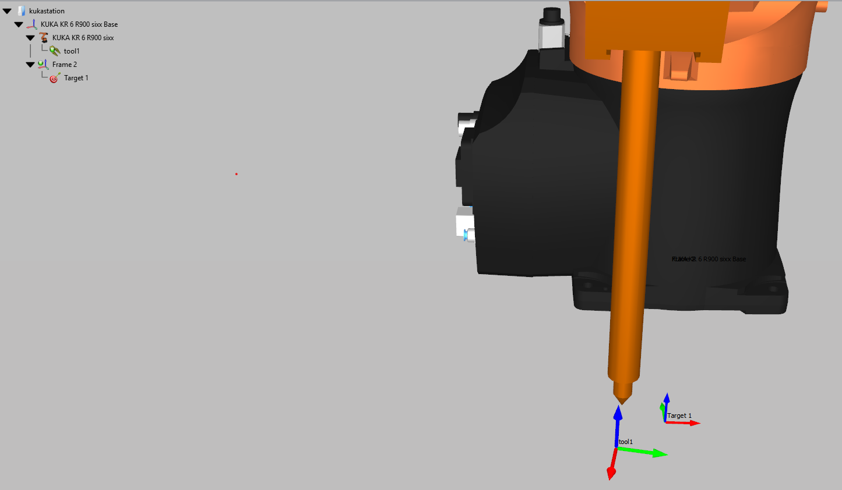
But while creating target using C# api the target is not created in tool direction, why?(Target creating in robot base direction)
Target is created along tool direction(this is what we want )

