Host PC

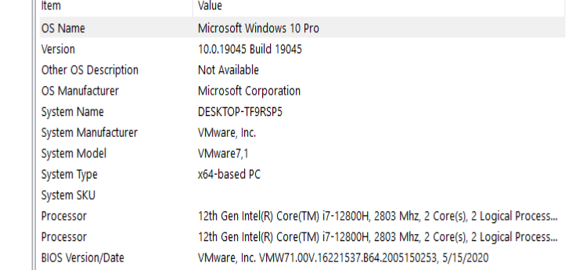

VM workstation

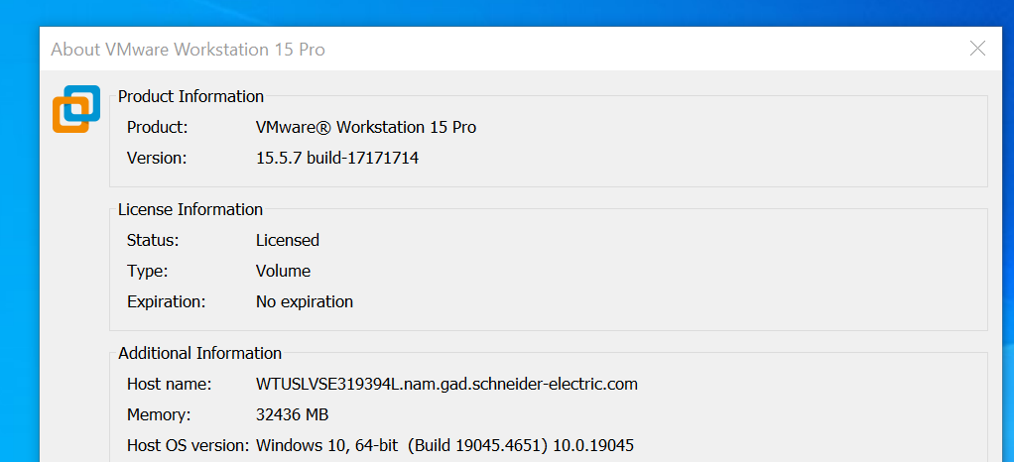

VM windows version

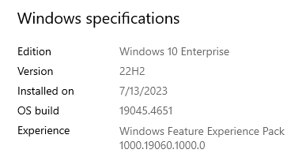

Launches but then shuts down from desktop icon.

Complains when started per below.

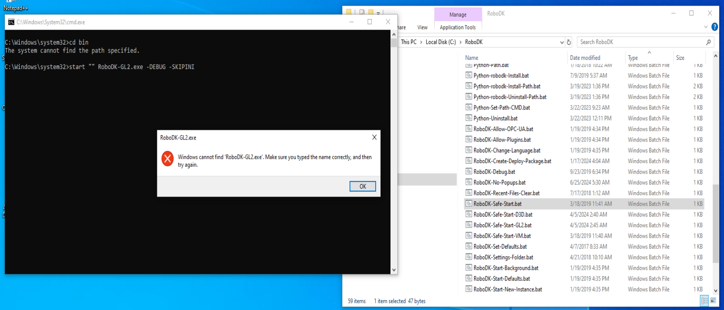

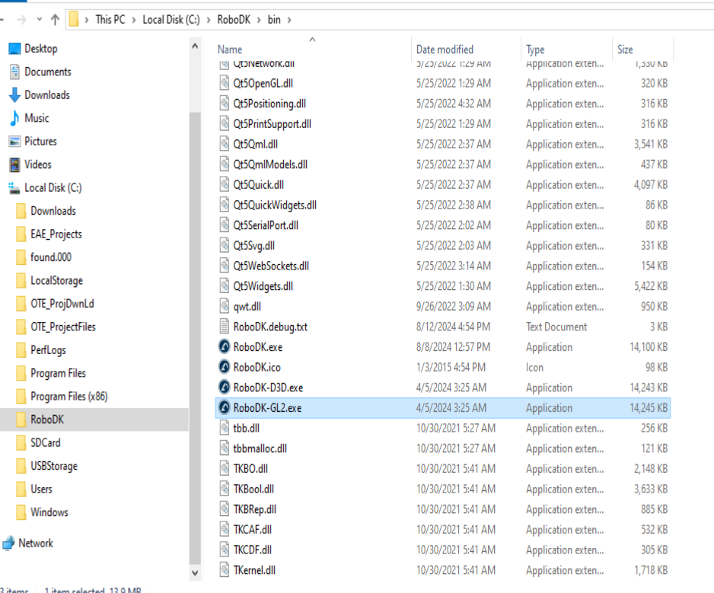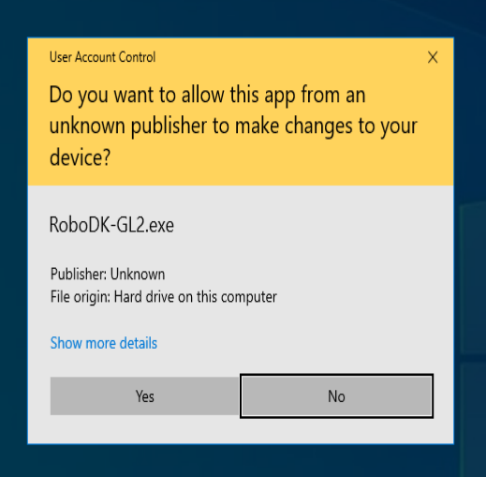

Confirm yes to Run as Admin, RoboDK starts and then shuts down.

Running RoboDK-Debug.bat as administrator fails to start.